10/3/2023

Tharsika Srisenthivel

Assignment 1 Data Visualisation

Contents

Policies and Procedures 2

Excel 3

Workbook Protection 3

Data format 3

Create a table 4

Filter a table 4

PivotChart 5

Edit a Chart 5

Moving chart & rename Worksheet 6

Top 20 Sorting 7

Bar chart for top 20 ranking countries 7

Macro 8

Header and Footer 8

Tableau 9

Data import and relationship 9

Visualisations 9

Top 20 Countries by Smartphone Users 9

Top 20 Country by GDP 10

Top 20 Country by Life Expectancy 11

Top 20 Country by GDP in 2019 12

Top 20 countries by GDP in 2003-2018 13

Total GDP in 2019 for the top 20 countries 14

Total smartphone users for the top 20 countries 14

Life expectancy vs GDP per capita 15

Dashboards 16

Story 17

Reflections 18

References 19

# Policies and Procedures

Personal data constitutes any information pertaining to an individual that possesses the potential for their identification through such data. This category incorporates a wide array of data points which includes but not limited to names, identification numbers, dates of birth, genders, geographic location data, email addresses, etc. These details, although seemingly innocuous on their own, hold enormous significance in the realm of privacy and data security.

In recognition of the importance of safeguarding personal data, the European Union took a momentous step on May 25, 2018, by instituting the General Data Protection Regulation (GDPR). This monumental legislation established a rigorous framework for privacy and data protection, mandating strict guidelines for the responsible handling of personal information. It serves as a global benchmark in the realm of data protection, setting a precedent that reverberates far beyond European borders.

Furthermore, national legislation, such as the Data Protection Act (DPA), fortifies the defence of personal data. The DPA imposes strict regulations governing the utilisation of individual data by organisations, businesses, and governmental entities. This legal framework plays a pivotal role in shielding the rights of individuals, ensuring that they can exercise independence in deciding what information to keep private and what to disclose.

The gravity of maintaining data security cannot be overstated. A breach in data can wreak havoc on an organisation's reputation and financial stability. Such breaches have the potential to degenerate or corrupt databases, release sensitive and confidential information into the public domain and deliver data into the wrong hands. Consequently, businesses may face significant financial losses as they deal with compensating those adversely affected by the breach.

In light of these imperatives, data analysts shoulder a considerable responsibility. They are entrusted with preserving the integrity of customer and company data, safeguarding the reputation of the organisation, and maintaining its financial stability. Therefore, data analysts must adhere to strict policies and ethical principles. They must exclusively work with authorised data and abstain from accessing or utilising unauthorised information, thus ensuring the sanctity and security of the data they handle. In doing so, they contribute to the collective effort of upholding the fundamental right to privacy and dignity in the digital age.

# Excel

## Workbook Protection

The image below demonstrates a password being set on the workbook to protect confidential data and stop unauthorised assess.

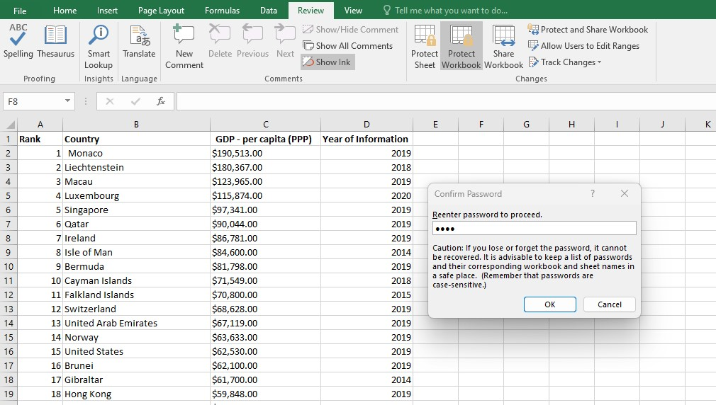

This was accomplishable by clicking on the ‘Review’ heading, then ‘Protect Workbook’.

## Data format

Column C in the GDP worksheet has been changed from dollars to pounds. This the achieved by the following steps

1. Highlight column C
2. Right click and select ‘Format Cells…’
3. Select the ‘Number’ tab
4. In the Category section, select ‘Currency’
5. Next to ‘Symbol’, click on the drop down menu.
6. Click on £
7. If the ‘Decimal Places’ is not already on 2, then enter ‘2’
8. Click ‘OK’

Please view the image below of the currency changed in Column C.

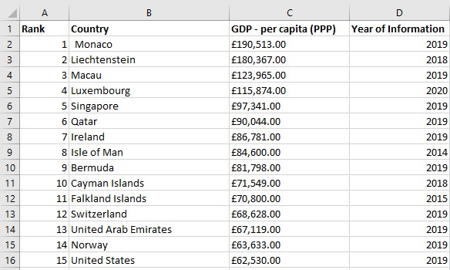

## Create a table

To create a table, the following steps were completed

1. Click into a field with the data
2. On the keyboard, press ‘Ctrl’ and ‘A- This will select the whole table.
3. Select the ‘Insert’ tab
4. Click on ‘PivotTable’
5. In the pop up, select ‘New Worksheet’
6. Select ‘OK’

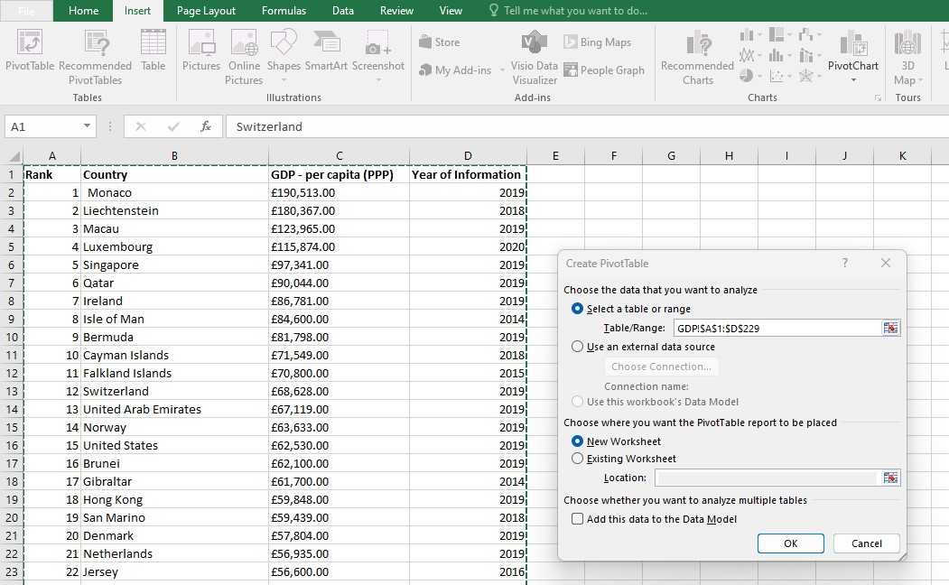

## Filter a table

The below image shows a table with only information for 2019.

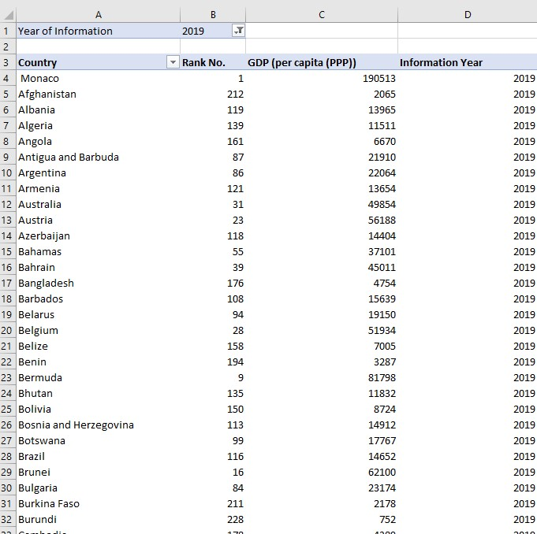

This was accomplished by selecting ‘Rank’, ‘Country’, ‘GDP- per Capita (PPP)’ and ‘Year of information in the ‘PivotTable Fields’. After that, to select information for 2019 only, in the ‘PivotTable Fields’, hover over ‘Year of Information’ and click on the drop down menu, then untick ‘Select All’ and scroll down and click ‘2019’ only. Finally drag the ‘Year of information’ field to the ‘Filters’ section.

## PivotChart

To create a chart, the following steps were taken

1. Be on the pivot table worksheet
2. Click on ‘Insert’ and in the ‘Charts’ section, click ‘PivotChart’
3. 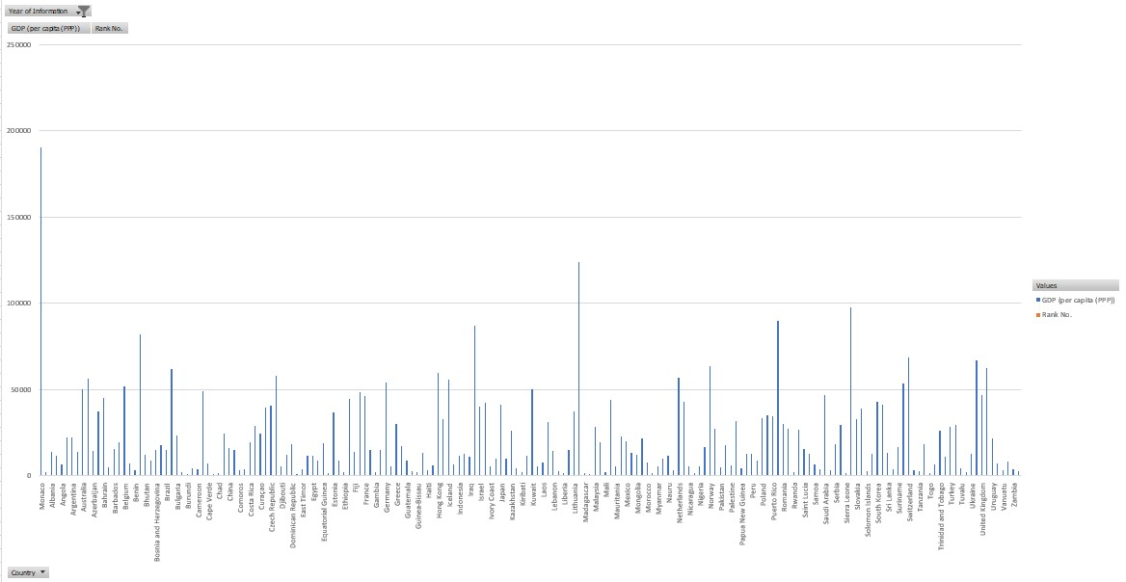In the pop up select a suitable chart

To present a chart with only Rank, Country and GDP- Per Capita (PPP), right click on the ‘Year Information’ button and select ‘Remove Field’.

The chart above represents a Clustered Column Chart with data on Rank, Country and GDP- Per Capita (PPP).

## Edit a Chart

To create the chart more visually pleasing, the following steps were undertaken:

1. To add a title, click the chart then click on and select ‘Chart Title’
2. The buttons on the chart was removed by right clicking on one button and selecting ‘Hide All Field Buttons on Chart’.
3. Click on the chart and using the select ‘Axis Titles’ to add and label the axis
4. Double click on the X Axis to open ‘Format Axis’, then click on ‘Axis Options’ and in the ‘Display Units’ select ‘Thousands’
5. In the ‘Format Axis’, set the minimum to ‘200000.0’
6. Click on the chart and then select the paint icon below the icon, then in the ‘Style’ tab, select a design.
7. 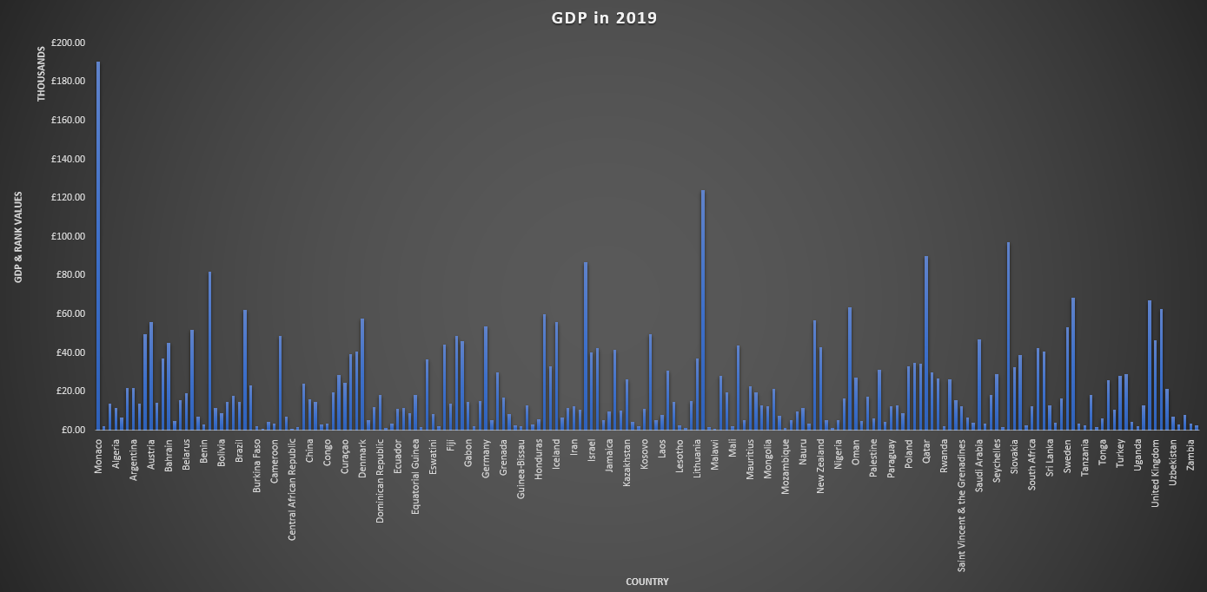Click on the Plot Area (lines in the background of the chart) and use the delete key to delete the lines.

## Moving chart & rename Worksheet

To move the chart into a new Worksheet, click on the chart and use the keys ‘Ctrl’ and ‘C’ to copy the chart. Then click on the next to other worksheets to create a new worksheet. After that use keys ‘Ctrl’ and ‘V’ to paste the chart. After that, double click on the new Worksheet to rename it.

## Top 20 Sorting

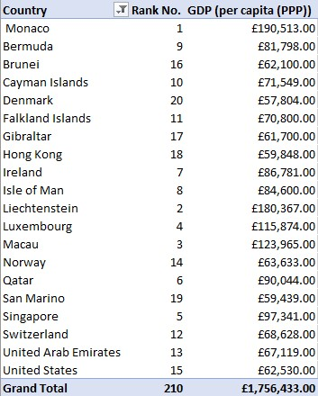The below image shows the top 20 highest ranking countries in the GDP data worksheet

This was achievable by the following steps:

1. Click on the arrow next to the ‘Country’ column title,
2. Select ‘Value Filters’
3. Click ‘Top 10…’
4. In the Top 10 pop up, change the 10 to 20 and by to GDP (per capita (PPP))
5. Click ‘OK’

## Bar chart for top 20 ranking countries

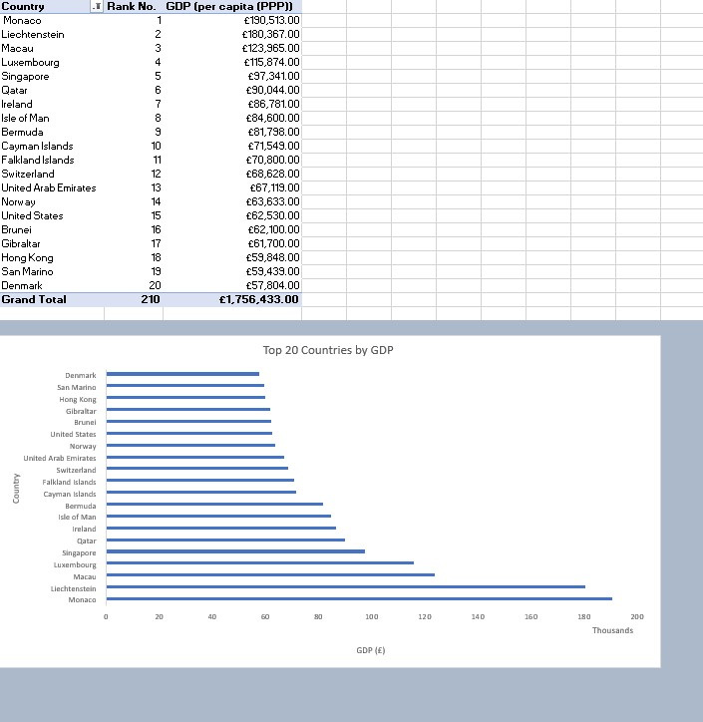As mentioned in the PivotChart section on page 5, the same steps were undertaken to create a Bar Chart. Once the chart was created, it was dragged to relocate underneath the PivotTable. After that, the chart background was highlighted and coloured. Please view the image below:

## Macro

Firstly, using ‘Shapes’ in the ‘Illustrations’ section of the ‘Insert’ tab, three buttons were created; a rectangle, oval and triangle. Then, text was added to specify the purpose of the buttons. This was accomplished by right clicking on the shape and then selecting on ‘Edit Text’. Please view the buttons created in the image below:

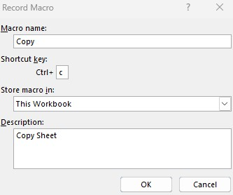To add a Copy Marco, the following steps were concurred:

1. Highlight the table and chart
2. Click ‘View’ tab then ‘Macros
3. Click ‘Record Macro’ to open pop up
4. Rename Macro name to ‘Copy’
5. Type ‘c’ under ‘Shortcut Key’
6. Type ‘Copy sheet’ in ‘Description’ section

Then the Macro was assigned to the ‘Copy’ button by right clicking the button, then selecting ‘Assign Macro..’. After this, in the Assign Macro pop up, click ‘Copy’ and then ‘OK’

## Header and Footer

To add a header and a footer, the ‘View’ tab was selected, then in the ‘Workbook views’ section, the ‘Page Layout’ button was clicked.

In this view, a header and a footer was added to the worksheet.

# Tableau

## Data import and relationship

‘The Wealth of Nations’ data set was imported and a relationship was created using the ‘Country’ column as it was a common column amongst all three data sets. After that, the data types were checked for each data set.

## Visualisations

### Top 20 Countries by Smartphone Users

The chart below demonstrates the top 20 counties which has the highest smartphone user.

The following steps where completed to create this chart:

1. Double click on ‘Country (Smartphones)’
2. Double click ‘Smartphone Users’
3. Click on ‘Show Me’ on the top right hand side and select ‘packed bubbles’
4. Drag ‘Country (Smartphones)’ into the filter section.
5. Click on the ‘Top’ tab and then click on ‘By field’ and change ‘10’ into ‘20’
6. Click ‘Apply’ then ‘OK’
7. Drag ‘Smartphone Users’ to label
8. Drag ‘Country (Smartphone)’ into ‘Colour’
9. Click on ‘Colour’ and then ‘Edit Colours…’
10. 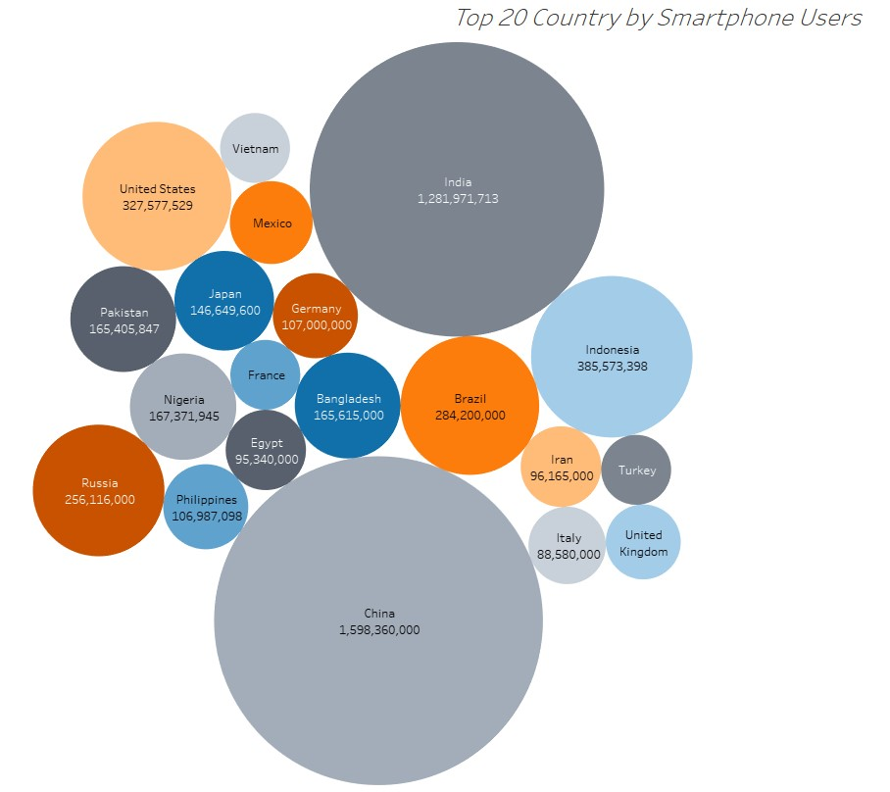Under ‘Select Colour Palette’, select ‘Colour Blind’
11. Click ‘Assign Palette’ then ‘Apply’ then ‘OK’

### Top 20 Country by GDP

This Bar chart was achieved by the following steps:

1. Double click on ‘Country’
2. Double click ‘GDP – per capita (PPP)’
3. Click on ‘Show Me’ on the top right hand side and select ‘Horizontal Bars’
4. In the ‘Rows’, click on the arrow next to ‘Country’ and click ‘Filter…’
5. Click on the ‘Top’ tab and then click on ‘By field’ and change ‘10’ into ‘20’
6. Click ‘Apply’ then ‘OK’
7. At the top click to sort the bars descending by GDP
8. Drag ‘GDP- Per capita (PPP)’ to label
9. 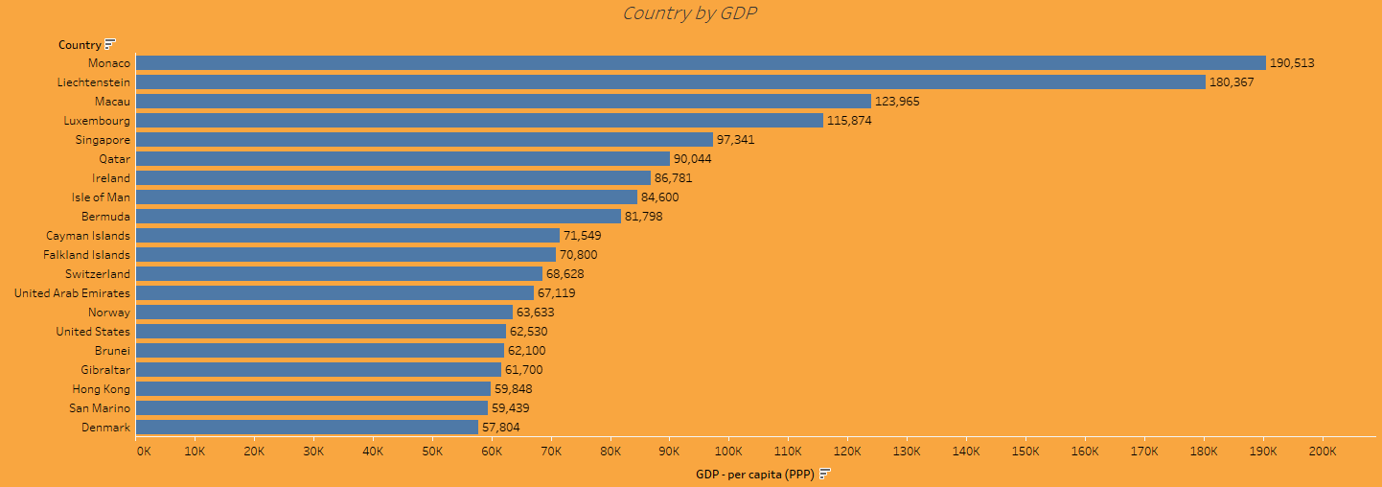Go to ‘Format’ then ‘Shading’ then click on the drop down next to ‘Worksheet’ and select orange colour

The chart above illustrated the top 20 counties which has the highest GDP.

### Top 20 Country by Life Expectancy

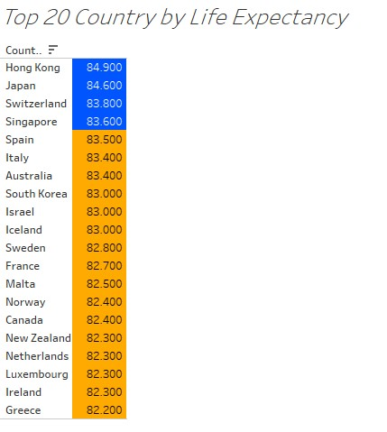The chart below was created to identify the top 20 countries with the highest life expectancies:

This was attained by the following steps:

1. Double click on ‘Country (Life expectancy)’
2. Double click ‘Life expectancy at birth’
3. Click on ‘Show Me’ on the top right hand side and select ‘highlight tables’
4. Drag ‘Country (Life expectancy)’ into the filter section.
5. In the ‘Rows’, click on the arrow next to ‘Country (Life Expectation)’ and click ‘Filter…’
6. Click on the ‘Top’ tab and then click on ‘By field’ and change ‘10’ into ‘20’
7. Click ‘Apply’ then ‘OK’
8. At the top click to sort the bars descending by GDP
9. Drag ‘Life Expectancy at birth’ into ‘Colour’
10. Click on ‘Colour’ and then ‘Edit Colours…’
11. Under ‘Palette’, select ‘Custom Diverging’
12. Select the left colour square and select orange
13. Select the right colour square and select blue
14. Tick ‘Stepped Colour’ and select 2 steps
15. Click ‘Apply’ then ‘OK’

### Top 20 Country by GDP in 2019

The chart provides information on the top 20 countries with the highest GDP in 2019. This was achieved by the following steps:

1. Double click on ‘Country’
2. Double click on ‘Year of Information’
3. Double click ‘GDP – per capita (PPP)’
4. Click on ‘Show Me’ on the top right hand side and select ‘Horizontal Bars’
5. At the top click to change the orientation of the bars
6. In the ‘Columns’, click on the arrow next to ‘Year of Information and click ‘Filter…’
7. Click on ‘None’ and tick ‘2019’
8. Click ‘Apply’ then ‘OK’
9. In the ‘Columns’, click on the arrow next to ‘Country’ and click ‘Filter…’
10. Click on the ‘Top’ tab and then click on ‘By field’ and change ‘10’ into ‘20’
11. Click ‘Apply’ then ‘OK’
12. At the top click to sort the bars descending by GDP
13. Drag ‘GDP- Per capita (PPP)’ to label
14. Drag ‘Country’ to Colour
15. Click on ‘Colour’ and ‘Edit Colours…’, then under ‘Select Colour Palette’, select ‘Colour Blind’
16. Click ‘Apply’ then ‘OK’

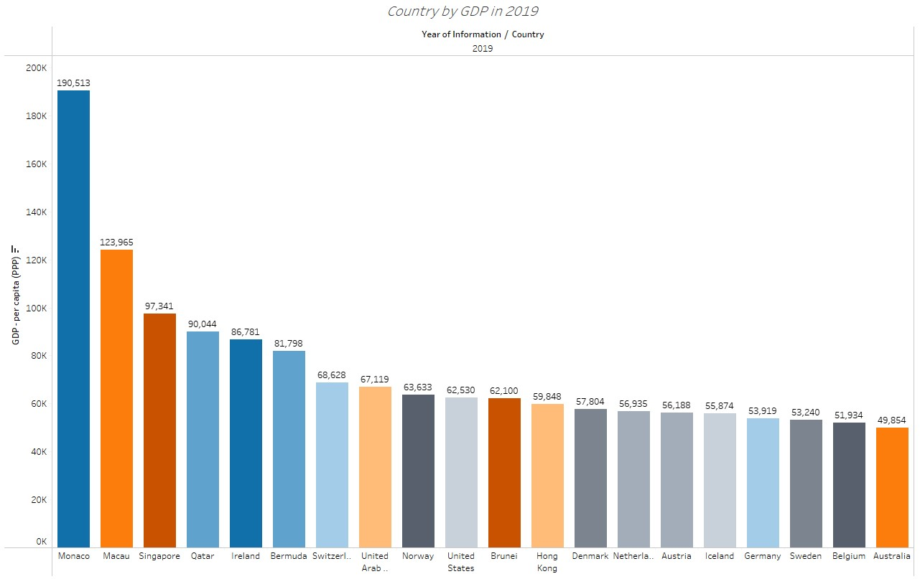

### Top 20 countries by GDP in 2003-2018

The chart below provides information on the top 20 countries with the highest GDP in 2019. This was achieved by the following steps:

1. Double click on ‘Country’
2. Double click ‘GDP – per capita (PPP)’
3. Drag ‘Year of Information’ to ‘Filters’
4. Tick 2003 to 2018
5. Click ‘Apply’ then ‘OK’
6. Click on ‘Show Me’ on the top right hand side and select ‘Packed Bubbles’
7. Drag ‘Country’ into ‘Filters’
8. Click on the ‘Top’ tab and then click on ‘By field’ and change ‘10’ into ‘20’
9. Click ‘Apply’ then ‘OK’
10. Drag ‘GDP- Per capita (PPP)’ and ‘Year of information’ to label
11. Drag ‘Country’ to Colour
12. Click on ‘Colour’ and ‘Edit Colours…’, then under ‘Select Colour Palette’, select ‘Colour Blind’
13. Click ‘Apply’ then ‘OK’

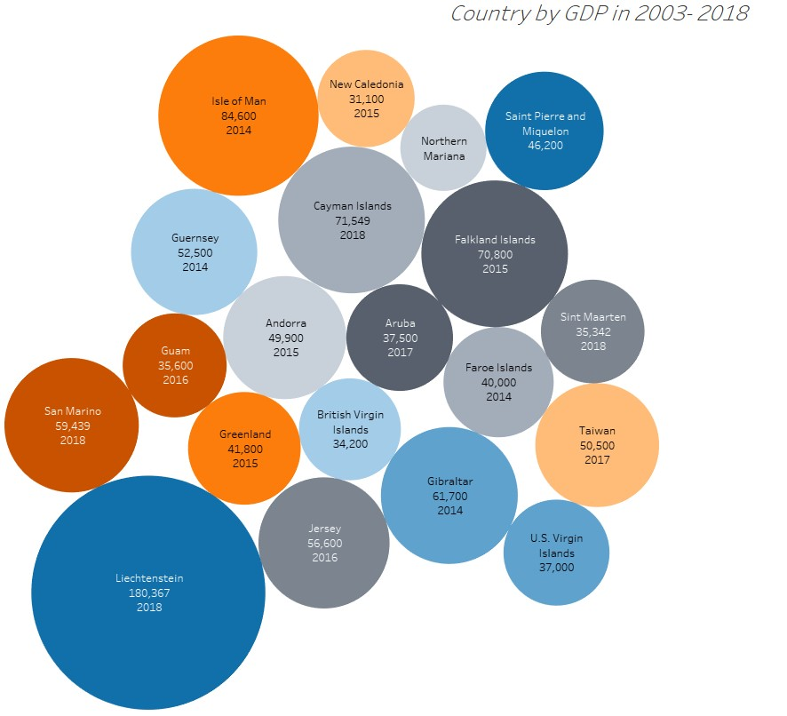

### Total GDP in 2019 for the top 20 countries

The image below represents the total GDP in 2019 for the top 10 countries:

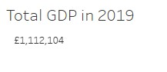

This was determined by the following steps

1. Drag ‘Year of Information’ to ‘Filters’
2. Tick ‘2019’
3. Click ‘Apply’ then ‘OK’
4. Drag ‘Country’ into ‘Filters’
5. Click on the ‘Top’ tab and then click on ‘By field’ and change ‘10’ into ‘20’
6. Click ‘Apply’ then ‘OK’
7. Drag ‘GDP – per capita (PPP)’ into ‘Text’
8. Right click on ‘SUM (GDP- per capita (PPP)’ and click ‘Format…’
9. Under Pane and then ‘Default’, select ‘Numbers’
10. Click ‘Currency (Custom) and change ‘Decimal places’ to ‘0’

### Total smartphone users for the top 20 countries

The total number of smartphone users were gathered for the top 20 countries. This was created using similar steps as in ‘Total GDP in 2019 for the top 20 countries’ section on page 13.

The steps are as follows:

1. Drag ‘Country’ into ‘Filters’
2. Click on the ‘Top’ tab and then click on ‘By field’ and change ‘10’ into ‘20’
3. Click ‘Apply’ then ‘OK’
4. Drag ‘Smartphone Users’ into ‘Text’

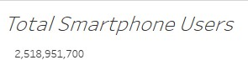

### Life expectancy vs GDP per capita

This chart below shows the GDP and life expectancy trend. To create this chart, the steps below were used:

1. Select ‘GDP- per Capita’ column and drag it into ‘Columns’
2. Select ‘Life expectancy’ column and drag it into ‘Rows’
3. Drag ‘Country into ‘Colour’ under Marks
4. Drag ‘Country into ‘Shape’ under Marks
5. Click on the arrow next to ‘Country’ in Filters, then ‘Edit Filter…’
6. In the ‘General’ tab, click on ‘Null’ then tick ‘Exclude’
7. Select ‘Top’ tab and then click on ‘By field’ and change ‘10’ into ‘20’
8. Click ‘Apply’ then ‘OK’

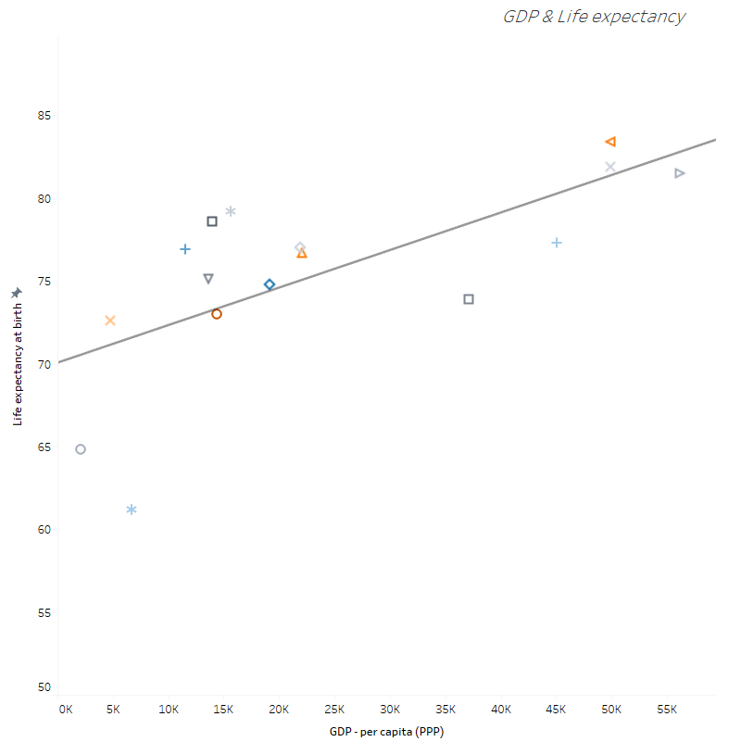Then a trend line was added by selecting the ‘Analysis’ menu then ‘Trend Lines’ and ‘Show Trend Lines’.

## Dashboards

To create dashboards, click on  which is situated on the bottom of the application. After that, to bring the visuals into the dashboard, drag and drop the sheets from the left panel, into the blank dashboard.

Then, to allow the visual to be positioned anywhere around the dashboard, the following steps were taken:

1. Click on the visual
2. Select the arrow on the visual
3. Click on ‘Floating’

After this, the visuals were resized using the lines around the visual.

Finally, a suitable title was added on the dashboard by renaming the dashboard sheet and selecting ‘Show dashboard title’ on the bottom left of the dashboard panel.

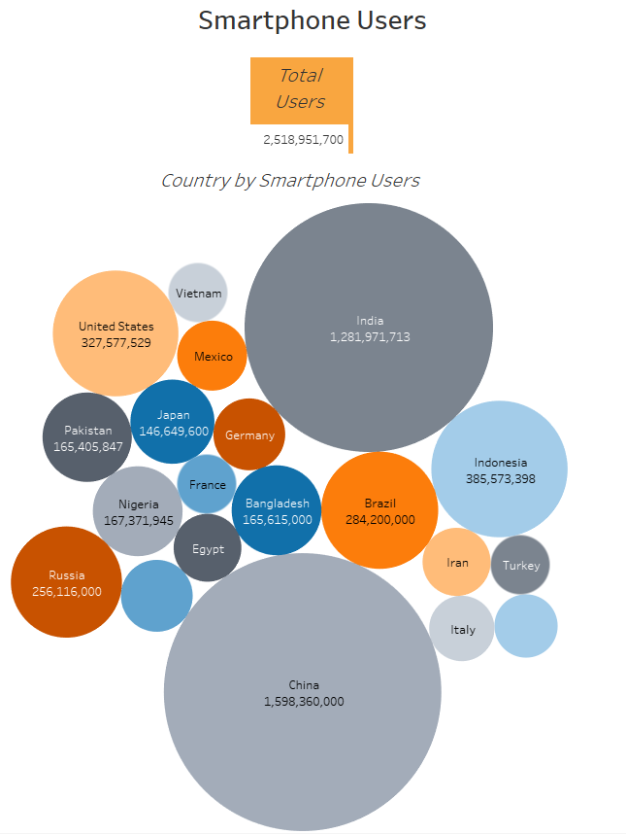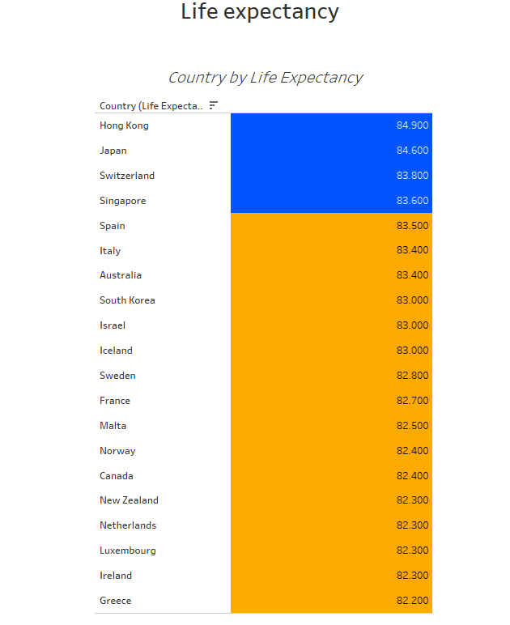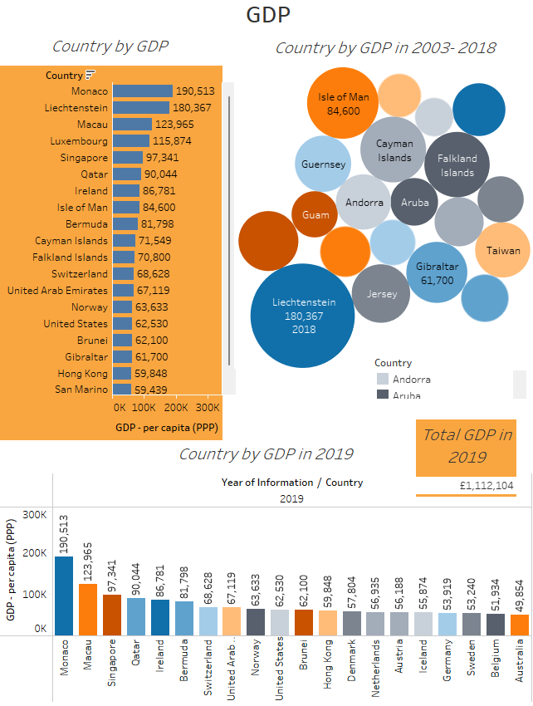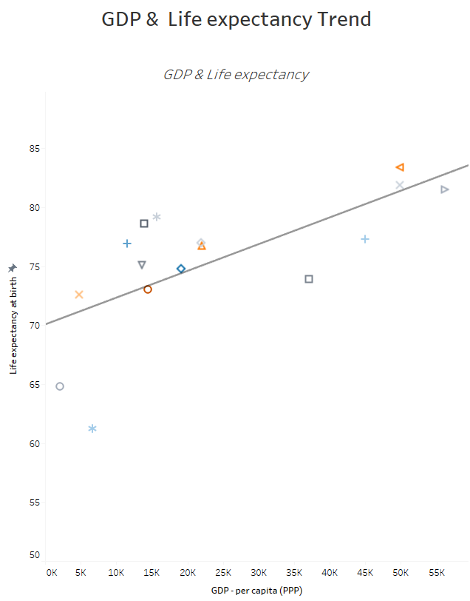

## Story

To create a story, click on  which is located next to the dashboard icon at the bottom of the application. After that, to bring the dashboards into the story, drag and drop a dashboard from the left panel, into the blank story and name it with a caption in ‘Add a caption’ grey box. To add more than one dashboard, click ‘Blank’ on the left panel.

Finally, a suitable title was added on the story by renaming the story sheet and selecting ‘Show title’ on the bottom left of the story panel.

To view the story, please click on the link below:

[The Wealth of Nations | Tableau Public](https://public.tableau.com/app/profile/tharsika.srisenthivel/viz/TheWealthofNations_16958369180900/Top20countriesforGDPSmartphoneusersLifeExpectancy?publish=yes)

# Reflections

While engaged in the Excel portion of the project, an issue emerged during the execution of the Macro task. My task was to successfully execute the Macro within Excel. However, a persistent problem arose as my Excel application kept abruptly shutting down during the execution process. In response to this challenge, I proactively took the initiative to address the situation. I renamed the file and converting it to the .xlsm format. This decision effectively resolved the issue, enabling me to not only execute the Macro seamlessly but also to successfully complete the entire task, contributing to the overall progress of the project.

In the course of my work with the Tableau platform, I undertook various visualisation tasks. My primary task was to create a total of four visualisations but I went above and beyond and created eight. These visualisations were diversified, with four of them focusing on the GDP dataset, two centred around the Smartphone dataset, one dedicated to the Life Expectancy dataset and the last one combining both GDP and Life Expectancy data. To accomplish these tasks, I applied my knowledge in Tableau to design and craft these visual representations. The outcome of my efforts was a collection of informative and insightful visualisations that contributed valuable insights to the project.

In the context of my work with data visualisations, I've identified areas for future growth and development. One of my key objectives is to expand my repertoire of visualisations by creating more combined visuals, which blend different datasets to provide richer insights. Additionally, I aim to enhance my skills and knowledge in Tableau to enable the creation of more complex and sophisticated visuals. To achieve these goals, I plan to invest time and effort into learning advanced Tableau techniques, exploring data integration strategies, and staying up-to-date with the latest techniques in data visualisation. By pursuing these actions, I anticipate that I will not only improve my proficiency in Tableau but also unlock the capability to produce more intricate and informative visuals.

In conclusion, this assignment has been a valuable learning experience during which I acquired and put into practice a wide range of skills. Notably, Tableau has proven to be an invaluable tool, simplifying the process of translating complex business inquiries into visually compelling and concise representations. These newly learned abilities not only contributed to the successful completion of the project but also serve as a foundation for continued growth and effectiveness in future data analysis endeavours.

# References

<https://www.gov.uk/data-protection#:~:text=The%20Data%20Protection%20Act%202018%20is%20the%20UK's%20implementation%20of,used%20fairly%2C%20lawfully%20and%20transparently>

<https://www.gov.uk/data-protection#:~:text=The%20Data%20Protection%20Act%202018%20is%20the%20UK's%20implementation%20of,used%20fairly%2C%20lawfully%20and%20transparently>

<https://www.kaspersky.com/resource-center/definitions/data-breach>